Project 3 Documentation

Antonio E Ramirez

University of Maryland Global Campus

26 April 2020

# Approach

As always, I took the approach of ensuring all of the course materials were read and understood. I did any additional research that I needed regarding the concepts prior to beginning on the project. I then read through the project requirements pdf to get a good understanding of what was expected and what the end state was. After this I went to the discussion boards to see if any valuable information had been posted, or see if any other students had already encountered any issues. This keeps me from doing any unnecessary work or repeating the same mistakes as others. After this I read through the Project 3 Approach document, and as always it was extremely helpful. This was used as a guide to help me get through this deceptively large project. It also gave some “milestones” to hit along the way. I found myself revisiting the course videos many times as I struggled through this project.

# Test Plan

To test my program, I used the test cases included in the approach document, as I found them highly applicable. I struggled immensely with this project, and unfortunately could not complete is to my satisfaction, or to satisfy the test cases. As I go through each test case, I will explain the aspect being tested, and if it failed, I will give a hypothesis as to why I think it failed and how I think it could be resolved.

Test Case 1:

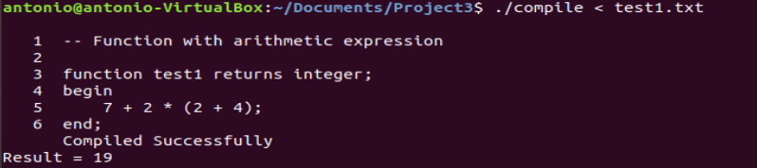

This was a pass. The result was compared to the provided course video, and the same result was achieved. This tested basic arithmetic expressions.

Test Case 2:

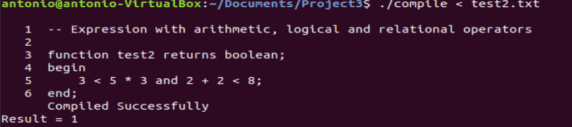

This was a pass. The result was compared to the provided course video, and the same result was achieved. This tested basic arithmetic, logical, and relational expressions.

Test Case 3:

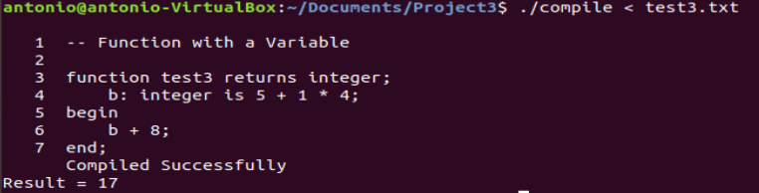

This was a pass. The result was compared to the provided course video, and the same result was achieved. This tested basic arithmetic expressions with the inclusion of a vaiable.

Test Case 4:

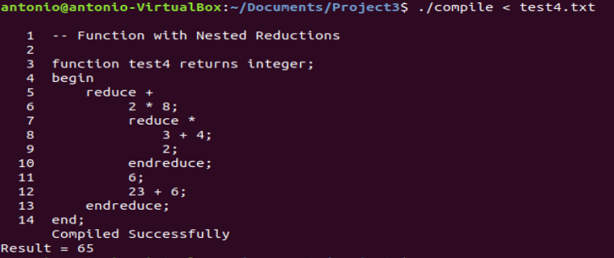

This was a pass. The result was compared to the provided course video, and the same result was achieved. This tested a reduction.

Test Case 5:

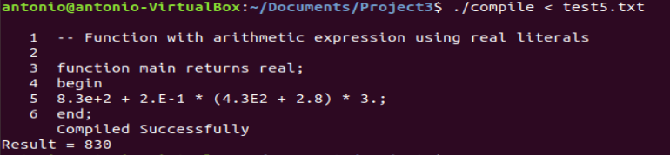

This was a fail. The actual result should be 1089.68. I believe that the only item interpreted was the first one, 8.3e+2, and nothing else. This would give us our wrong result of 830. I struggled to get both the real and Boolean literals to work properly throughout the project, and I believe this to be the issue.

Test Case 6:

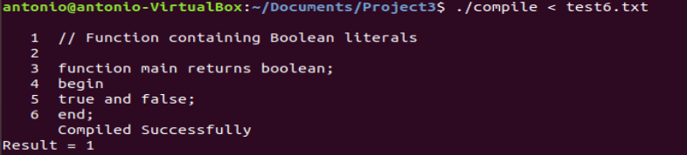

This was also a fail. The actual result should be 0, and our result was 1. In this program, 0 should equal false and anything else is true. Unfortunately, it appears that only the first true is evaluated, and thus giving us a result of 1. As previously stated, I struggled with real and Boolean literals. I know that the relational operator is not the issue as this is tested later on.

Test Case 7:

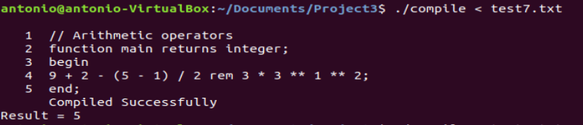

This test case was a pass. This tested a wider array of the arithmetic operators in our language. We were able to get the same result as the document without any errors.

Test Case 8:

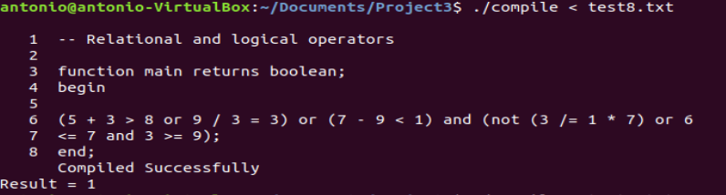

This was a pass. This verified that the fail from test case 6 was not related to the relational or logical operator and was in fact the literal. We achieved the same result as the document with no errors.

Test Case 9:

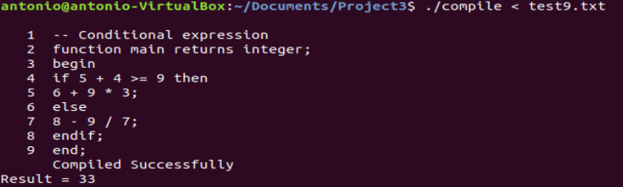

This was a pass. This shows a conditional expression, and we were able to get the same result as the document with no errors.

Test Case 10:

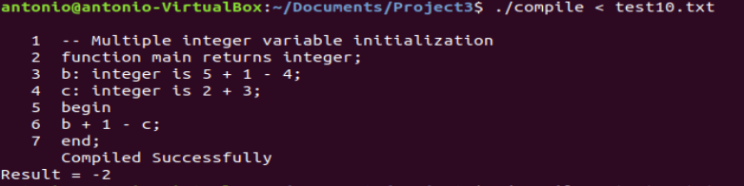

This was a pass. This tested a function with multiple variables. These variables were not input by the user. We achieved the same result as the document.

Test Case 11:

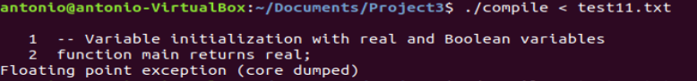

This was a fail. Once again, I believe this to be an issue with the real and Boolean aspects of the program. This error was unable to be resolved. I was unable to pinpoint an exact area as to why this was happening. We know that the variable aspect of the program functions due to previous tests, and this is inline with our suspicions of issues with real and Boolean. The test case is as follows:

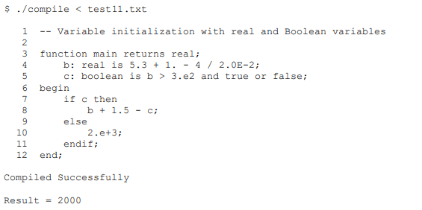

Test Case 12:

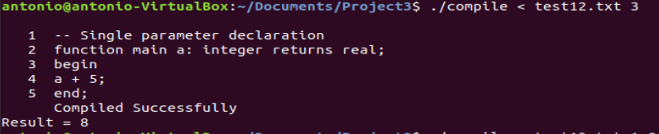

This was a semi-pass. We are testing the ability to have user input parameters, and we achieved the correct result of 8. However, when we enter the intended 3.6 as the parameter, we end up with the wrong result. This shows that we are effectively able to read user input data for the parameter from the console, but yet again are having issues with the real.

Test Case 13:

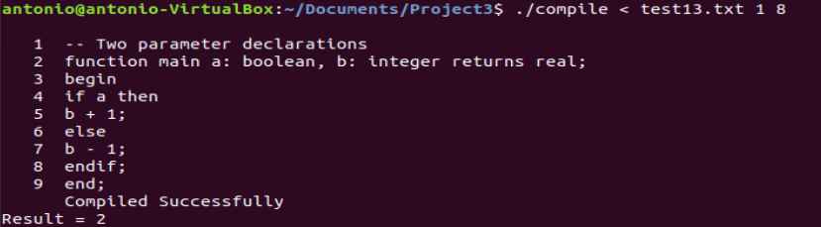

This was a fail. We are unable to read 2 user input parameters. This is more than likely due to being unable to store the input somehow. We see that the first condition is met, and then the operation is again ran on a instead of b.

Test Case 14:

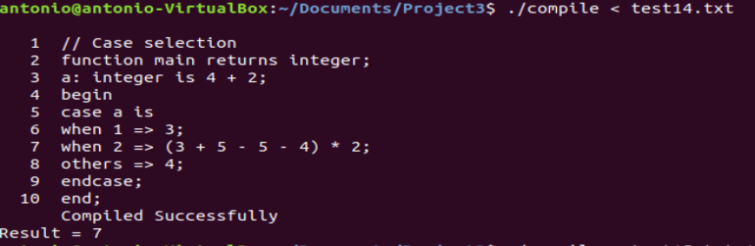

This was a fail. We were unable to properly handle the cases within our program. I saw the guidance posted in the discussion boards, but I was unable to properly apply it.

Test Case 15:

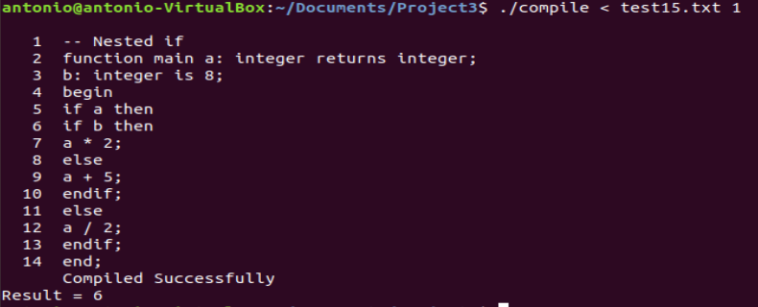

This was a fail. We were able to effectively process a single if statement, but it appears to not work with nested if statements. We see the first condition met, but not the second, which leads to a result of 6 from 1 + 5.

# Lessons Learned

I struggled immensely with this project and overall, I am not happy with the outcome. I was unable to meet all the project requirements. I will continue to work on this project until it can pass all the provided test cases. Going forward, I need to be more proactive about reaching out for help. I did not do so and resorted to hours upon hours of researching in a circle and getting nowhere. I know it will be something simple that held me up. I learned a lot about being proactive and reaching out for help, and the consequences when you fail to do so. Going forward I also need to give myself more time to work on these projects. I did not anticipate so much time to be spent on research and trying to resolve errors. Hopefully I can get some very constructive feedback as I have in the past and fix the issues with the program. This was a definite wake-up call and I would like to learn from my mistakes and move on to the next project.